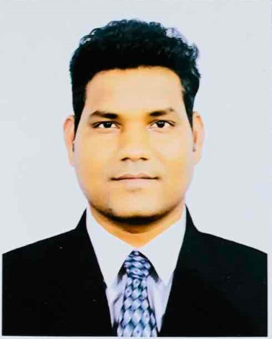

# Contact Details

 New Delhi, India

 +91 9911332432

 +91 9911332432(WhatsApp)

[ankurshrivastava1987@gmail.com](mailto:webmail.ajb@gmail.com)

Ankur

Shrivastava

**AB**

Senior Developer, Tech Lead

Master of Computer Application (MD University, INDIA)

**Experience : 11+ years**

Expert in .Net Core, C#, ASP.NET MVC, ADO.NET, SQL, NodeJS, ReactJS

Domain : Fintech, ERP, CMS, HR Domain, Oil & Gas, Real Estate

Work Locations : India, Myanmar, Thailand

Achievement : Won multiple awards for contribution in projects in most of the companies

Number of successful project deployment in production : 11

Language : English, Hindi & Thai (Speak)

**Professional Experience**

 [https://www.linkedin.com/in/ ankurshrivastava1987](https://www.linkedin.com/in/ankurshrivastava24/)

# Skills

.Net Core, ReactJS, NodeJS, ASP.Net MVC, ASP.Net Core, C#, Web API, Rest API, SQL Server, Express JS, Ext JS, WPF, WCF, jQuery, JSON, AJAX, ADO.Net, LINQ, Entity Framework, Agile Software Development, Microsoft Azure, AWS and Google Cloud Computing and Team foundation server. Telerik UI

.Net Core & .Net Framework

Advanced ASP.NET MVC & API



Advanced C# & SQL



Advanced

NodeJS & ReactJS



2021-12 -2023-07

2021-06 -

2021-12

## ExxonMobil, Bangkok, Thailand

**Full Stack Developer**

Worked as an individual contributor in development of .Net Web API and frontend using ReactJS for WEBCAT project. It’s a training platform used by employee and contractor to educated themselves about daily work at site of ExxonMobil. Performed Third party integration to transfer data to other platform in the company. Worked with multicultural team located globally and. did support for many other projects in the company assigned to team.

**FPT Software, Da Nang, Vietnam**

A**ssociate Technical Architect**

Meeting with clients for Analysis of requirement, Estimation, Designing database creating architecture & Coding, Testing. Worked for UBT Australia client to provide estimation of their projects. Help team in various other projects.

Azure DevOps & AWS



Upper intermediate

jQuery, JavaScript , Entity Framework



Upper intermediate

Agile, Scrum



Upper intermediate

2017-12 -

2021-03

2016-01 -

2017-11

2014-08 – 2016-01

2012-03-2014-06

**Internet Wallet Ltd.(OK$), Yangon, Myanmar**

## Technical Lead

Tech Lead for backend team of Fintech project **OK$.** Which is Mobile payment application widely used in. Myanmar.

Worked on developing ecommerce application and site for the company other business **1-STOP-MART.** Worked and support and provide guidance to other project of the company related ERP and Travel domain.

**Created window based application for various task backed team**

**Crimson Interactive Pvt. Ltd. Mumbai, India**

## Senior Software Engineer

Worked on **Client servicing project** built-in house project, which is group of multiple project of web and WPF based window projects. This is used to handle C.S client application, payment, account, client servicing, startup services, Inquiry, assignment and invoice management etc. I have upgraded this project from B2C to B2B business currently working on lab campaign module as an enhancement in the software to build and gain more business for the company. Worked as senior developer and provide guidance to junior team members.

Worked on Window based application for inhouse team related to accounting and project management.

**Datamatics Global Services Pvt. Ltd. , Mumbai, India**

**.NET Consultant**

Worked for client **United Nation Women**, project call result management system. Unwoman runs their various programs in multiple countries to improve the condition of women in various countries. Strategic Plan, Strategic Note, Flexi Program, Monitoring, Annual Reporting, System Reports, Search functionality, Dashboard charts, Budget Allocation,

Atlas Integration are the main module of the project.

Worked as individual contributor in the team and also help juniors

**Classic Informatics, New Delhi, India**

**Senior Software Engineer**

Worked as developer and senior developer capacity in below projects. all project are from UK and US and involved direct communication with client.

1.<http://ace-a-metric.com>

2.<http://hitrateapproval.demos.classicinformatics.com>

3.[http://ex2mediaplayer.demos.classicinformatics.com](http://ex2mediaplayer.demos.classicinformatics.com/)